Proposal for AAST IT Infrastructure for Carbon Reporting and VVB Establishment

# Vision

1. **For the Current Project**:  
   To establish a robust IT system for AAST University that facilitates accurate and efficient carbon footprint calculations, reporting, and continuous monitoring, ensuring compliance with international standards.
2. **For the Future VBB**:  
   To position AAST as a trusted Validation/Verification Body (VVB) capable of independently verifying and validating carbon projects, leveraging advanced technologies including AI, IoT, and remote imagery to meet local and regional market demands.

# Goals

**Current Project: Generating AAST University’s Carbon Footprint Report**

1. **Ensure Operational Efficiency**
   * Transition from manual data collection to automated workflows.
   * Streamline the calculation and reporting processes for AAST’s carbon footprint.
   * Enable real-time monitoring of emissions and energy use across campus via a dashboard.
2. **Improve Accuracy and Transparency**
   * Collect accurate and well-structured data on energy use, waste, and emissions on AAST’s campuses.
3. **Strengthen AAST Stakeholder Awareness**
   * Provide university stakeholders (faculty, students, and staff) with insights into AAST’s carbon footprint.
   * Promote sustainability initiatives adopted by AAST based on data-driven decisions.

**Future Goal: Establishing AAST as a VVB**

1. **Build a Scalable VVB IT Infrastructure**
   * Design a system that supports validation and verification of external carbon projects.
   * Ensure compliance with ISO standards and international carbon markets.
2. **Enable Advanced Verification Tools**
   * Leverage AI, IoT and other technologies to independently verify land use, emissions, and energy data for carbon projects.
   * Develop automation tools to streamline the validation/verification process.
3. **Expand Market Presence**
   * Establish AAST as a regional leader in carbon project verification.
   * Build capabilities to support both emerging and established methodologies.

Phased Approach and Deliverables

The project will be implemented in **three distinct phases**, focusing on specific, measurable deliverables for both the current need (AAST’s carbon footprint reporting) and the long-term vision (establishing AAST as a VVB).

# Phase 1: Data Acquisition and Reporting Foundation (0–4 Months)

**Focus**: Building the foundation for efficient data collection, reporting, and monitoring for AAST’s carbon footprint, while establishing scalable systems for future VVB operations.

**Deliverables for AAST University’s Carbon Reporting:**

1. **Core Data Acquisition System**:
   * **Centralized Database**: A secure database with role-based access for data owners, administrators, and stakeholders.
   * **Data Collection Templates**: Standardized templates for energy use, emissions, and waste data to be used across all departments.
2. **Structured Data Submission**:
   * **User-Friendly Forms**: Build an intuitive web-based interface for departments to submit numeric data (e.g., energy use, waste).
   * **Batch Uploads**: Enable CSV/Excel uploads for departments with large datasets.
   * **APIs**: Develop APIs for automated submission from connected systems.
3. **Role-Based Dashboards**:
   * **Data Owners**: Department-specific dashboards to manage and verify submitted data.
   * **Stakeholders**: High-level dashboards to monitor AAST’s overall carbon footprint and sustainability initiatives.
   * **Administrators**: Comprehensive dashboards for monitoring progress, generating reports, and identifying areas for improvement.
4. **Automated Reporting Tools**:
   * **Report Formats**: Generate carbon footprint reports in PDF and Excel formats.
   * **Visualization Tools**: Provide bar charts, pie charts, and trend analysis to simplify complex data interpretation.

**Deliverables for Future VVB Foundation:**

1. **Scalable IT Architecture**:
   * A flexible system framework to accommodate future modules for validating and verifying external carbon projects across industries (e.g., industrial, agricultural).
   * Ensure compliance with ISO standards for data management and reporting.
2. **Stakeholder Portal**:
   * Develop a portal for external stakeholders (e.g., project developers) to engage with AAST and access updates on sustainability efforts.

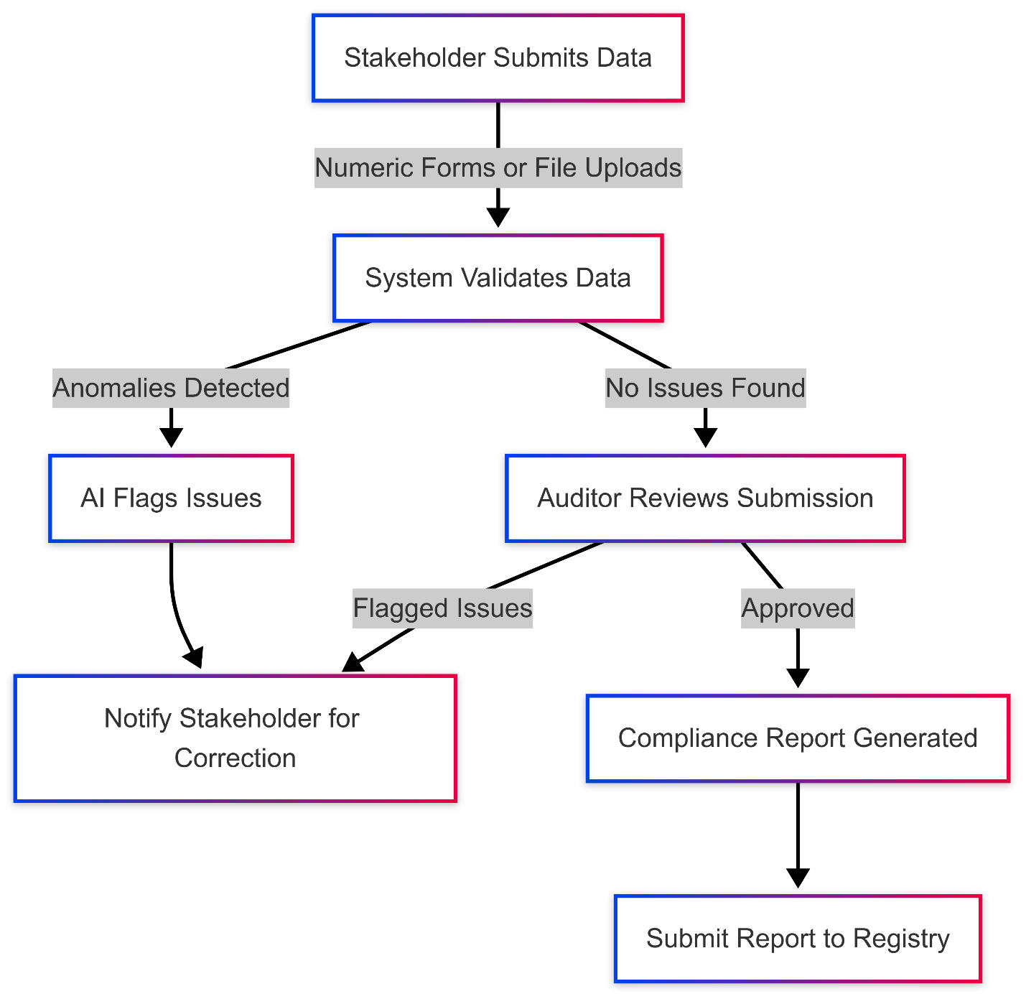

# Phase 2: Expansion with AI and IoT (6–12 Months)

**Focus**: Strengthening the system by integrating AI for data analysis, predictive modeling, and leveraging IoT tools for both internal reporting and external VVB capabilities.

**Deliverables for AAST University’s Carbon Reporting:**

1. **AI-Powered Insights**:
   * **Anomaly Detection Models**: Deploy AI models to identify outliers or inconsistencies in campus emissions data (e.g., energy spikes).
   * **Actionable Insights**: Provide administrators with recommendations to optimize energy usage and reduce waste.
2. **Predictive Analytics**:
   * **Emissions Forecasting**: Develop tools to predict future emissions trends based on historical data.
   * **Sustainability Evaluation**: Simulate the impact of proposed initiatives on AAST’s carbon footprint.
3. **IoT Integration**:
   * **Real-Time Monitoring Sensors**: Deploy IoT sensors on campus to monitor water usage, energy consumption, waste management, and emissions.
   * **Data Automation**: Automate the ingestion of IoT data into the centralized reporting system for real-time analysis.
   * **Alerts and Notifications**: Set up automated alerts for unusual spikes or anomalies detected by IoT sensors.

**Deliverables for VVB Establishment:**

1. **Advanced AI Models for Validation/Verification**:
   * **AI for Outlier Detection**: Train AI models to detect anomalies in external project data (e.g., energy use discrepancies).
   * **NLP for Document Analysis**: Use Natural Language Processing to extract emissions factors, project methodologies, and key data from uploaded project documents.
2. **IoT for Remote Monitoring**:
   * **IoT Deployment for External Projects**: Enable IoT integration for external projects to collect real-time emissions data.
   * **Automated Validation**: Automate the validation of incoming IoT data and flag inconsistencies for auditor review.
3. **Enhanced Dashboards**:
   * **Stakeholder Insights**: Provide external stakeholders with real-time compliance feedback and project monitoring metrics.
   * **Predictive Tools**: Integrate predictive insights to help project developers optimize their performance.
4. **Website Expansion**:
   * **Case Studies**: Publish success stories from AAST’s carbon reporting and VVB activities.
   * **Interactive Tools**: Develop features like carbon calculators and chatbots for stakeholder engagement.

# Phase 3: Advanced Automation and Market Integration (12–24 Months)

**Focus**: Achieving full-scale automation, blockchain integration, and positioning AAST as a leader in carbon markets.

**Deliverables for AAST University’s Carbon Reporting:**

1. **Advanced Automation**:
   * **Workflow Automation**: Automate sustainability reporting workflows to ensure consistent and timely updates.
   * **Smart Contracts for Campus Goals**: Implement blockchain-based smart contracts to track internal sustainability goals and automate compliance reporting.

**Deliverables for VVB Establishment:**

1. **Carbon Market Integration**:
   * **Market APIs**: Create APIs for seamless integration with carbon market platforms like Verra and Gold Standard.
   * **Automated Credit Issuance**: Automate the issuance of verified carbon credits for compliant projects.
2. **Smart Contracts for Compliance**:
   * **Blockchain Workflows**: Use Ethereum-based smart contracts to automate validation and verification workflows.
   * **Automated Approvals**: Enable automatic project approvals once all validation criteria are met.
3. **Scalability for Emerging Methodologies**:
   * **Support New Standards**: Enhance the system to accommodate new and emerging methodologies in carbon project validation.
   * **Market Expansion**: Position AAST as a preferred partner for regional and global carbon markets.

**Technology Stack**

| **Component** | **Technology** |
| --- | --- |
| **Frontend** | React.js for responsive user interfaces. |
| **Backend** | Python (FastAPI/Django) for scalable APIs. |
| **Database** | PostgreSQL for structured data and AWS S3 for document storage. |
| **AI Models** | TensorFlow for anomaly detection and NLP processing. |
| **Visualization** | Plotly Dash for dashboards and Google Earth Engine for geographic data analysis. |
| **IoT Integration** | MQTT protocol and IoT platforms (e.g., AWS IoT Core) for emissions monitoring. |
| **Satellite Imagery** | Google Earth Engine, Sentinel-2, or Landsat for land-use analysis. |
| **Blockchain** | Ethereum and Solidity for smart contracts. |

**Appendix: Terms and Concepts**

| **Term** | **Definition** |
| --- | --- |
| **VVB** | Validation/Verification Body - An entity that validates and verifies carbon project claims. |
| **Carbon Footprint** | The total amount of greenhouse gases emitted directly and indirectly by an entity. |
| **IoT Sensors** | Internet-connected devices that monitor real-time data, such as emissions or energy usage. |
| **Smart Contracts** | Self-executing programs on a blockchain that automate workflows based on predefined conditions. |
| **NLP** | AI technology that processes text to extract relevant information, such as emissions factors or project details. |